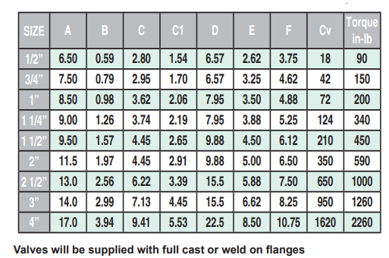
Dimensions - Flanged Class 600 Tri-Pro Series

