
Checklist for ordering 3-way and 4-way industrial valves
1. Valve Type & Configuration
- 3-way or 4-way (Circle one)
- Mixing or diverting function (Circle one)
- T-ported, L-ported (for 3-way), or X-ported (for 4-way) (Circle one)
- Flow pattern (See diagram below and circle the pattern you need)
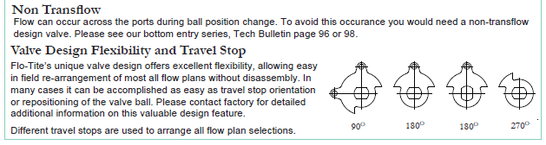
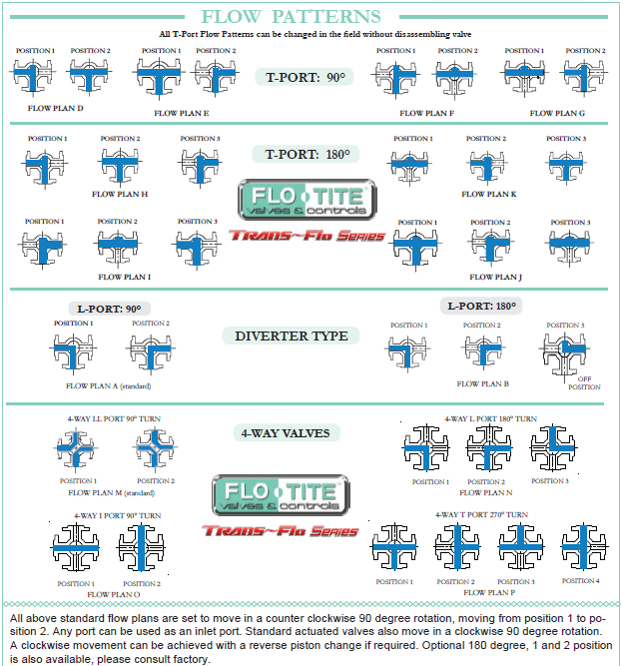

2. Valve Size & End Connections
- Pipe size (inches or mm) ___________________________
- End connections: flanged (ANSI, DIN), threaded (NPT, BSP), welded, tri-clamp (Circle One)
- Pressure rating (class 150, 300, PN16, etc.) ________________________________________

3. Material of Construction
- Body material (carbon steel, stainless steel, brass, PVC) ________________________________
- Ball, plug, or disc material _______________________________________________________
- Seat and seal material required (Super Tek, Super Tek III, TFM, PTFE, Metal) ______________________
- Stem material (if different) _______________________________________________________

4. Operating Conditions
- Operating pressure (bar, psi) (Circle One) _______________________________________________
- Operating temperature (°C, °F) (Circle One) _____________________________________________
- Type of media (Water, Gas, Steam, Slurry, Corrosive, Acid, Ammonia, food grade) (Circle One) _________________________
- Viscosity, solids content (if applicable) _________________________________________________

5. Actuation Method (Check which is Required)
  - Manual (lever, gear) (Circle One)
  - Pneumatic actuator (single or double acting) (Circle One)
  - Electric actuator (voltage, control signal) _______________________________________
  - Hydraulic actuator
  - Fail-safe requirements (spring return, battery backup, etc.)

________________________________________________________________________

6. Control & Accessories (Optional) Check the box if Required
- Positioners (electro-pneumatic, smart) _________________________________________________________________________
- Limit switches or feedback sensors _________________________________________________________________________
- Solenoid valves (for pneumatic actuators) _________________________________________________________________________
- Local or remote-control panel _________________________________________________________________________
- Locking devices or safety accessories _________________________________________________________________________

7. Standards & Certifications Required
- Design standards (API, ASME, ISO, DIN) (Circle One) __________________________________
- Fire-safe design (if needed) _________________________________________________________
- Fugitive emissions rating ___________________________________________________________
- ATEX, SIL, CE, or other certifications ________________________________________________
- Material test certificates, pressure test reports _________________________________________________________________________________
_________________________________________________________________________________

8. Special Requirements (Optional)
- Custom mounting or installation constraints _____________________________________________
- Coatings or surface treatments (for corrosion, hygiene) ____________________________________
- Traceability or documentation (for critical services) _______________________________________
- Spare parts or maintenance kits _______________________________________________________

9. Delivery & Logistics
- Required delivery date _____________________________________________________________
- Packing and shipping requirements (export, seaworthy, etc.) _______________________________
________________________________________________________________________________
- Site contact for delivery or installation _________________________________________________
________________________________________________________________________________

We thank you for the opportunity to quote you!

